**SOFTWARE TESTING ACTIVITY**

**SELENIUM GRID**

Name: JAYANTH KUMAR S

REG NO: 22MCAA27

Standalone:

* If we want to run Hub and Node in same machine, we can use this mode.
* Practical Demonstration:
  + Create any folder say Jars folder under any location say C Drive etc.
  + Download Selenium Standalone from official website and paste into above folder.
  + Download different Browser executables and paste them into the same above folder.
  + java -jar selenium-server--4.18.1.jar standalone
  + UI Version: http://localhost:4444

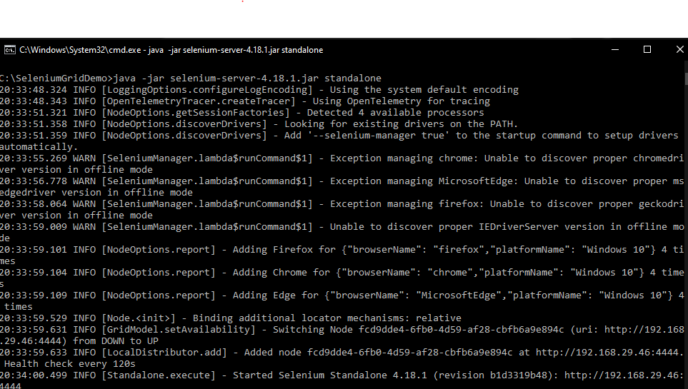

standalone selenium started.

in the selenium ui the node gets automatically created.

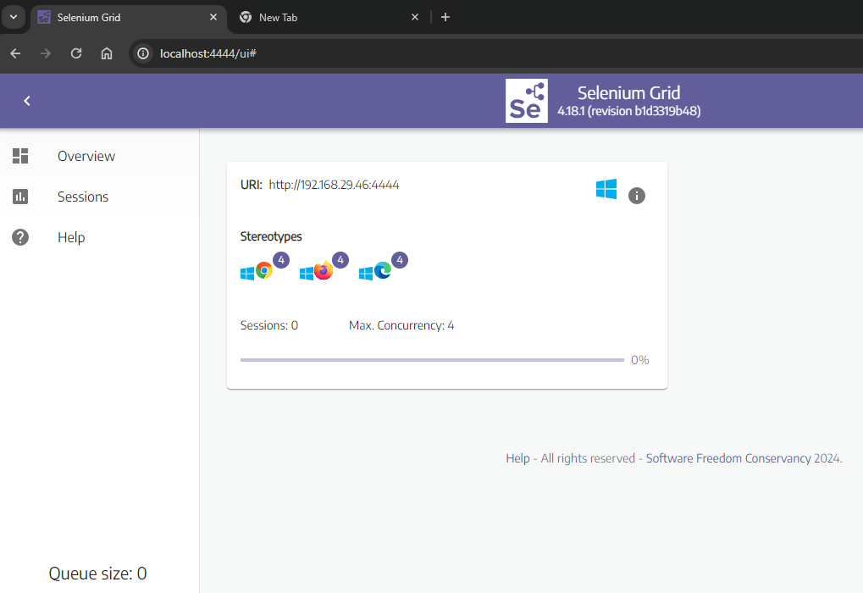

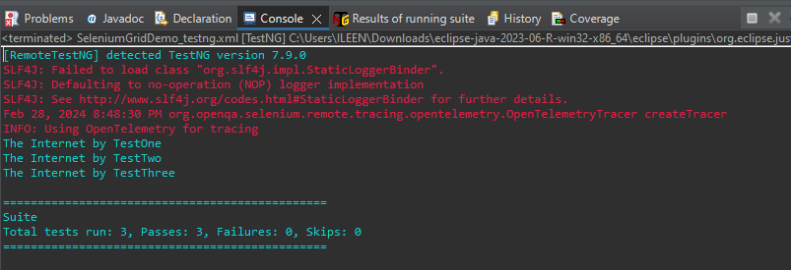

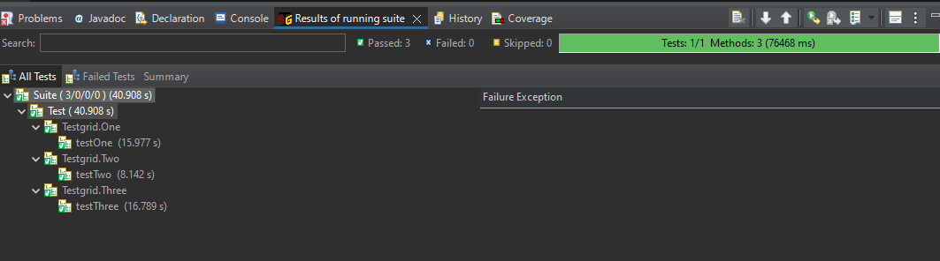

Hub setting:

* Hub and Node Mode:
  + Hub
    - Hub is the union of the following components:
      * Router
      * Distributor
      * Session Map
      * New Session Queue
      * Event Bus
    - Start Hub in the machine using:
      * java -jar selenium-server--4.18.1.jar hub
  + Node in same machine
    - java -jar selenium-server-4.18.1.jar node
  + Node in different machine
    - java -jar selenium-server--4.18.1.jar node --detect-drivers **true** --publish-events tcp://{hubIP}:4442 --subscribe-events tcp://{hubIP}:4443
    - hubIP - Displayed in the cmd logs on registering the hub

Selenium hub started

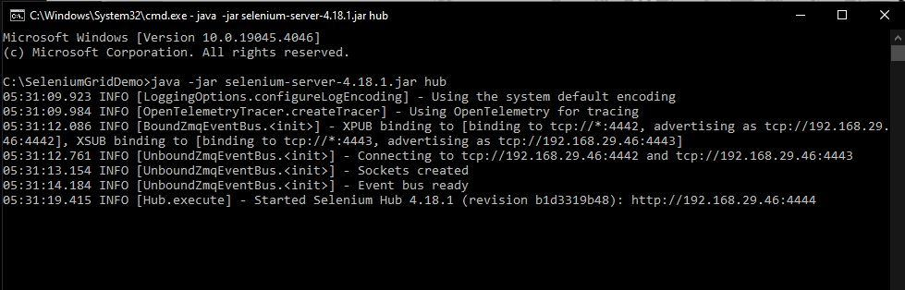

Selenium IU with no node created automatically

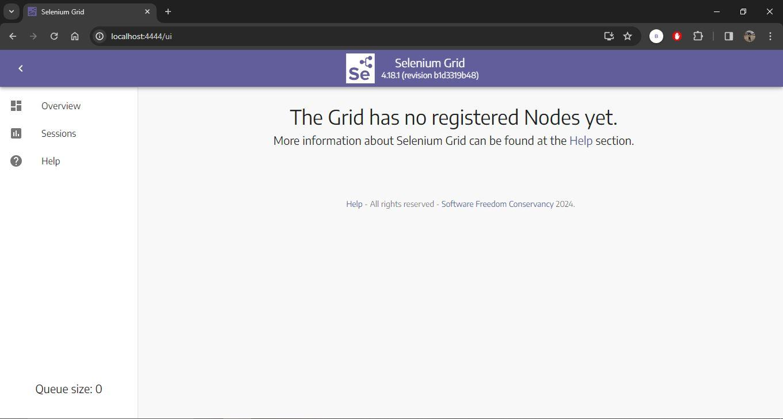

1)Node in same machine

java -jar selenium-server-4.18.1.jar node

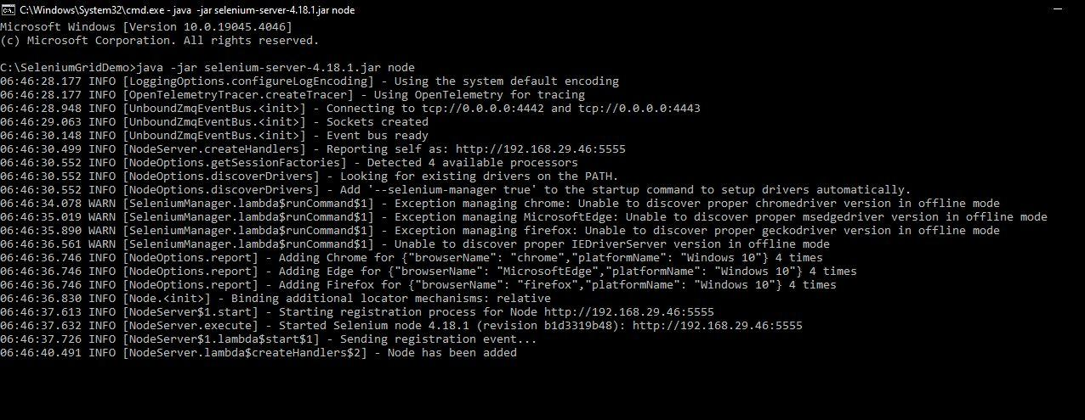

Here one node is being created.

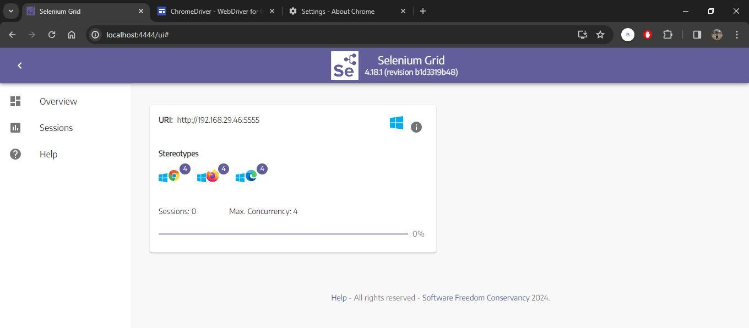

2)Node in different machine

* + java -jar selenium-server-4.18.1.jar node --detect-drivers **true** --publish-events tcp://{hubIP}:4442 --subscribe-events tcp://{hubIP}:4443
  + hubIP - Displayed in the cmd logs on registering the hub

hub created in one machine

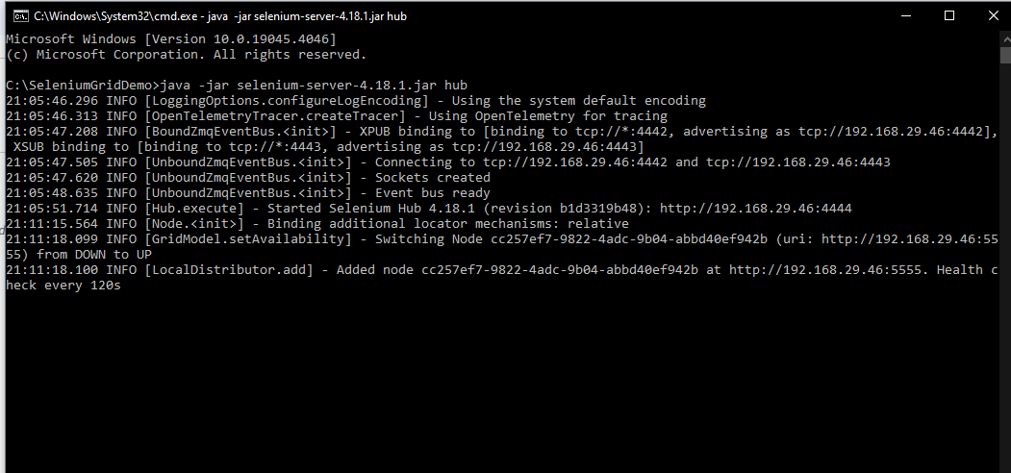

node has been added using different machine

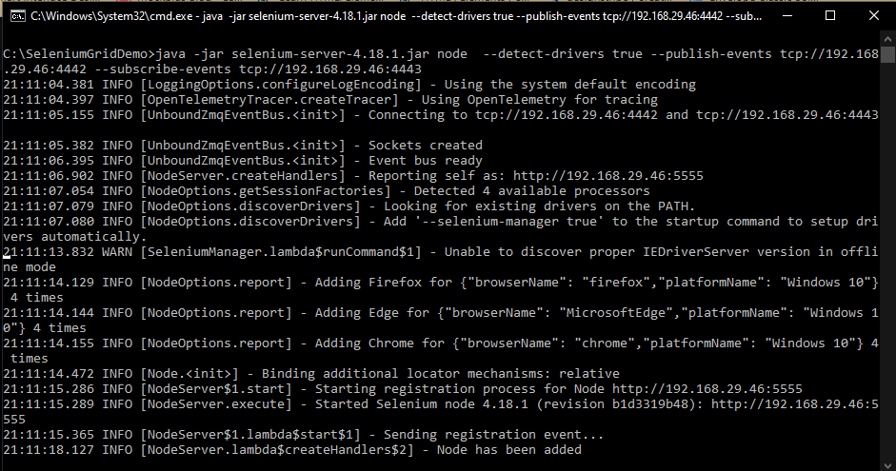

node is visible in hub ui

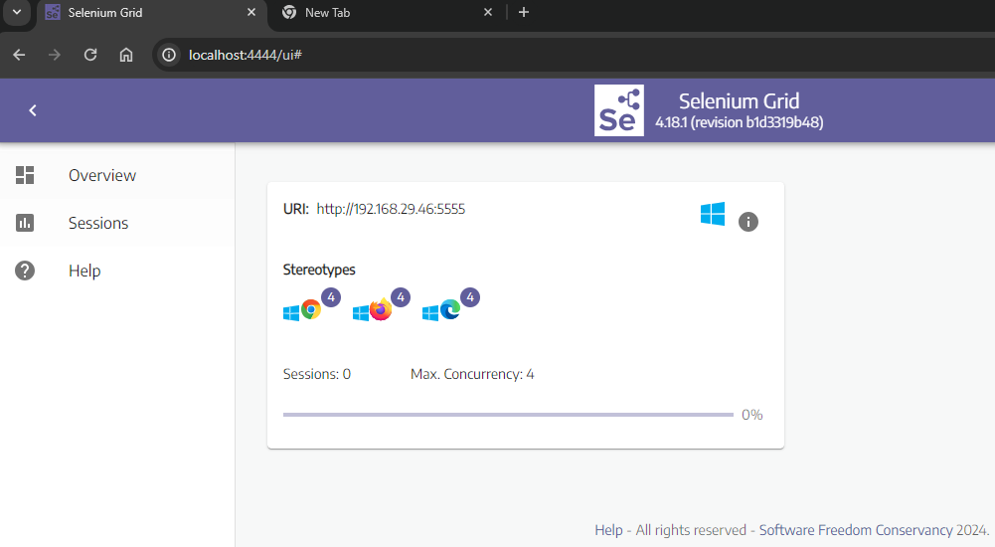

now we will run the test code

